# Use Case Details - Structured

Final versions of the requirements documents used for walk-throughs with the main stakeholders.

IDs can be anything from consecutive numbers to meaningful acronyms about what kind of use case this is and what system it is a part of.

## UC1 Withdraw Cash

Repeat this template for each use case to be documented.

### General info

#### Description:

Short summary that can be extracted and used in the use case summary page.

Client goes to machine with bank card to retrieve cash from account and gets receipt.

#### Actors: Client

The roles that can initiate this use case. It does not include participants.

#### Supporting roles/systems (other stakeholders): Bank

Sometimes called (supporting actors) and are other “actors” that are involved during the course of events. These can also be called interfaces.

#### Type: System

Options are: system | business | blended (business tasks interspersed with system tasks). Include the system name if several are used.

#### Pre-conditions:

Rules for beginning this use case: state of system prevents usage, must be testable. Or in a business use case, this must be the current state that has met a goal through another use case that this use case can now follow.

* Cash on hand in equal to or more than maximum withdrawal amount of $600 in ATM.
* No available funds in client's account.

### Scope info

#### Level: Goal

Options are: goal | partial goal | group of goals | group of partial goals. Goal level will comprise 90% of the use cases.

#### Includes:

The use cases that are extracted out of this use case and given a special name, so they can be reused. They are required to be a part of this use case. This use case can be considered a grouped use case if it includes one of a group of partial goal use cases.

#### Included in:

The use case(s) that uses this one as a necessary part of it.

#### Use cases grouped by this ID:

If it doesn’t have an included group above, then it will be a category for several use cases.

#### Grouped by: GUC1 Do Transaction

The group that has others like this one.

### Tracking info

#### Author: ATM class of 7/10/2020

#### Date created: 7/10/2020

#### Person and Date revised: ATM class of 7/10/2020 on 7/10/2020

### Project info

#### Design constraints: ATM chassis Bazinga 278385495

Pure business term descriptions are hard to write. Constraints describe Any kind of policy, infrastructure, time, location, budget, hardware, or software that must be accommodated by this process e.g. web site is required, SQL Server is required, location must be…, hardware must be…

#### Priority: High, 9 or 1st iteration

Priority will be by goal level or higher. Partial goal use cases will take their priority from the highest level that it is included in.

#### Value to sponsor: Reduce overhead costs of labor and facilities.

Value must be specified by the requirement that it is supporting for the business.

#### Sponsor: Mr. Big

Who is accountable for this use case being delivered successfully?

### Course of Events

The sequence of tasks in conversation format between actor and system. For best linking to other steps, start each number with a system task except for the trigger. Combine actor responses to system events when well. Rules are placed under the task unless they can be reused and then they are referenced and placed in a separate file.

The number of tasks per number is usually small and starts with the system or the role. Tasks are individually stated so the system/role can do multiple things but in separate sentences. The last task will prepare the state of the system so that this use case can be performed again. There will be no condition statements to branch into two separate use cases. There may be a section that is removed to a named partial use case and called an <<include>> to shorten the detailed use case.

References that can be used here to document anything other than a functional requirement are:

* **T#** - Text file item number – used for error messages and small prompts mostly on forms.
* **D#** - Design file item number – used for web pages, full screen menus, etc.
* **R#** - Report file item number – used for printed or on-screen report formats
* **\* -**  a Data Dictionary item – used to refer to data description and validation so that the detail doesn’t have to be specified here. Also bolded and colored is good.
* **Rule#** - Rule file item number – used to refer to process rules. Generally, this will follow one path only and another use case will pick up any other options. Some data validation rules find their way here but should be collected under the Data Dictionary. Unnumbered rules are not reusable and will just be defined below their functional requirement.

1. The use case starts when the actor inserts their card. The system reads and validates the card.
   1. **RULE** - Valid cards are …
   2. **RULE** - Mag stripe is read by reader.
2. The system prompts the actor for the PIN (SD#1). The actor enters PIN.
3. The system communicates with the bank to validate PIN. The bank confirms PIN is valid (with a response).
4. The system prompts actor with transaction menu (SD#2).
5. The actor selects Withdraw Cash.
6. The system prompts actor for amount to withdraw (SD#3). The actor enters amount to withdraw.
7. The system validates the amount.
   1. **RULE** - Multiples of $20.
   2. **RULE** - Maximum amount of withdrawal per transaction is $600.
   3. **RULE** - Maximum amount of withdrawal per customer per day (midnight to midnight) is $600.
8. The system subtracts withdrawal amount from cash on hand.
9. The system **prompts actor for account to withdraw from (SD#4).** The actor selects account to withdraw from.
10. The system communicates with the bank to validate available funds. The bank confirms available funds. The system logs the communication.
11. The system dispenses cash. The system prompts the actor to take cash. (SD#?) The actor takes the cash. The system logs dispensing the cash.
12. The system communicates with the bank to update actor's account. The bank confirms with an updated balance. The system logs the communication with the bank.
13. The system **provides actor with receipt (RD#1)**. The system prompts the actor to take receipt. (SD#?) The actor takes the receipt.
14. The system prompts actor for another transaction (SD#?). The actor chooses to terminate session.
15. The system ejects card and prompts actor to take their card. The actor to take card.
    1. RULE - Card is taken within 15 seconds -
16. The system prompts actor with idle screen after 10 seconds. (SD#0)

### Alternate flows (errors, exceptions)

The error flows are where a rule is broken, or something interrupts the normal “happy path” of the course of events. This often is during communication or other type of I/O.

* **Bad PIN entered** (#3) - The system increments the number of bad PIN entry retries. The system validates the maximum number possible of retries. The use case **continues** at #2.
  + RULE - Max number of PIN entry retries - 3.

If maximum number possible of retries is reached, system prompts user that card is retained. (SD#?) The system retains the card. The use case **continues** at #16.

* **Bad card inserted** (#1a) - The system prompts user that card is not usable at this ATM. The use case **continues** at #16.
* **Bad card inserted** (#1b) - The system prompts user for proper method to insert card. The use case **continues** at #16.
* **Cancel key is pressed** (#5-6, 9) - The system prompts the actor with end of session and signal actor with an annoying bell (SD#?). The use case continues at #15 after 10 seconds.
* **Error communication with bank…**
* **Error cash dispensing…**

### Alternate flows (extension points)

An exception to branching is when there is an optional <<extends>> of a partial use case. But the use case returns to where the option was taken.

* **Check balance** (#6) - The actor selects Check Balance option. The system communicates with the bank for balance amount. The system displays balance. The user confirms. The use case continues at #6.

### Post-conditions

What are your tests that tell you that this is a successful completion of a use case? It may be a repetition of one of the tasks or a file or document that has been completed. But there are minimal ways to complete the goal and there are very excellent ways to complete it. Put both down. Some people use MoSCow – must have, should have, could have instead of min and max conditions.

* Transactions were transmitted to bank successfully.
* Cash was dispensed.

### Notes/ Special Requirements

Any kind of quality, capacity, security, availability, disaster recovery information that is because of this use case. Maybe you also have ideas about design, or people who need to be checked with, etc.

Machine should have privacy shields of opaque plastic around keypad.

# Screen and report designs

1. Enter PIN 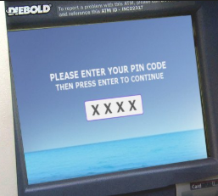
2. Main transaction menu 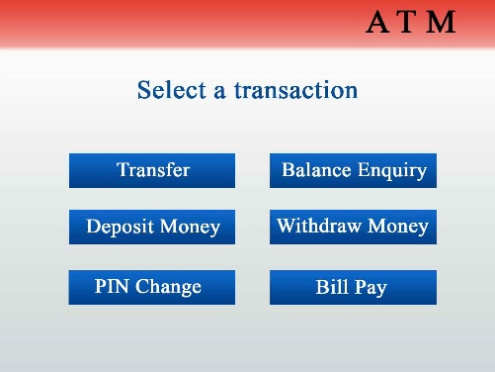

Report design #1